

A Project

Report On

**PLACEMENT MANAGEMENT SYSTEM**

By

**Suraksha Kharvi**

Batch : 2021-6258

Center : Banglore-S-Prayas

**Under The Guidance Of**

**Anjana Sarode**

Technical Trainer

**Edubridge**

**(School of coding)**

**Introduction :**

placement management web sites, provides information on placement providers and the placements and also keeps up to date information of all students. It is a platform where students can view and assess their opportunities.This project includes following modules

* **Admin login**
* **Admin index**
* **Placement details**
* **College details**
* **Student details**

I have developed this Application in Java, Springboot,SpringMVC , thymeleaf and MySQL. It’s a web-based projects so I have used HTML, CSS, JavaScript and Bootstrap also.

The main scope of the project is a total management and informative system, which provides the up- to-date information of all the students in the college.

The placement officer itself can carry out operations in a smooth and effective manner. They need not concentrate on record keeping. The college can maintain computerized records thus reducing paper work, time and money.

**Software Requirements:**

**Front end:** Java/J2EE technologies HTML, CSS, JavaScript, Bootstrap, springBoot,SpringMVC.

**Back end:** MySQL workbench 8.0.23CE.

**Middleware/Server:** Apache Tomcat v8.5.

**IDE:** Spring Tool Suite 4.0

**Browser:** Best result on Google Chrome.

**Operating System:** Window 10.

**Data Dictionary :**

* create database Placement.
* USE Placement1.
* create table login(id bigint primary key auto_increment,username varchar(255),password varchar(255)).
* insert into login(id,username,password)values(1,"Raksha","Raksha@29").
* select * from login.
* create table College(id bigint primary key auto_increment,collegename varchar(255),collegelocation varchar(255),collegeadmin varchar(255),collegeemail varchar(255));
* select * from College.
* create table Placement(id bigint primary key auto_increment,name varchar(255),college varchar(255),date varchar(255),qualification varchar(255),year varchar(255)).
* drop table Placement.
* select * from Placement.
* create table Student(id bigint primary key auto_increment,studentname varchar(255),course varchar(255),percentage numeric,mailid varchar(255),college varchar(255),roll bigint,qualification varchar(255),hallticketno numeric).
* Insert into Student(id ,studentname, course, percentage, mailid, college, roll, qualification,hallticketno)values(1,"ravina","BE","86","ravinakumaras@gmail.com",

"geck",24,"BE",5767).

* select * from Student.
* create table student_login(id bigint primary key auto_increment,username varchar(255),password varchar(255)).
* drop table StudentLogin.
* insert into student_login(id,username,password)values(1,"Raksha","Raksha@29");
* select * from student_login.

**Screenshorts :**

***Admin login page***

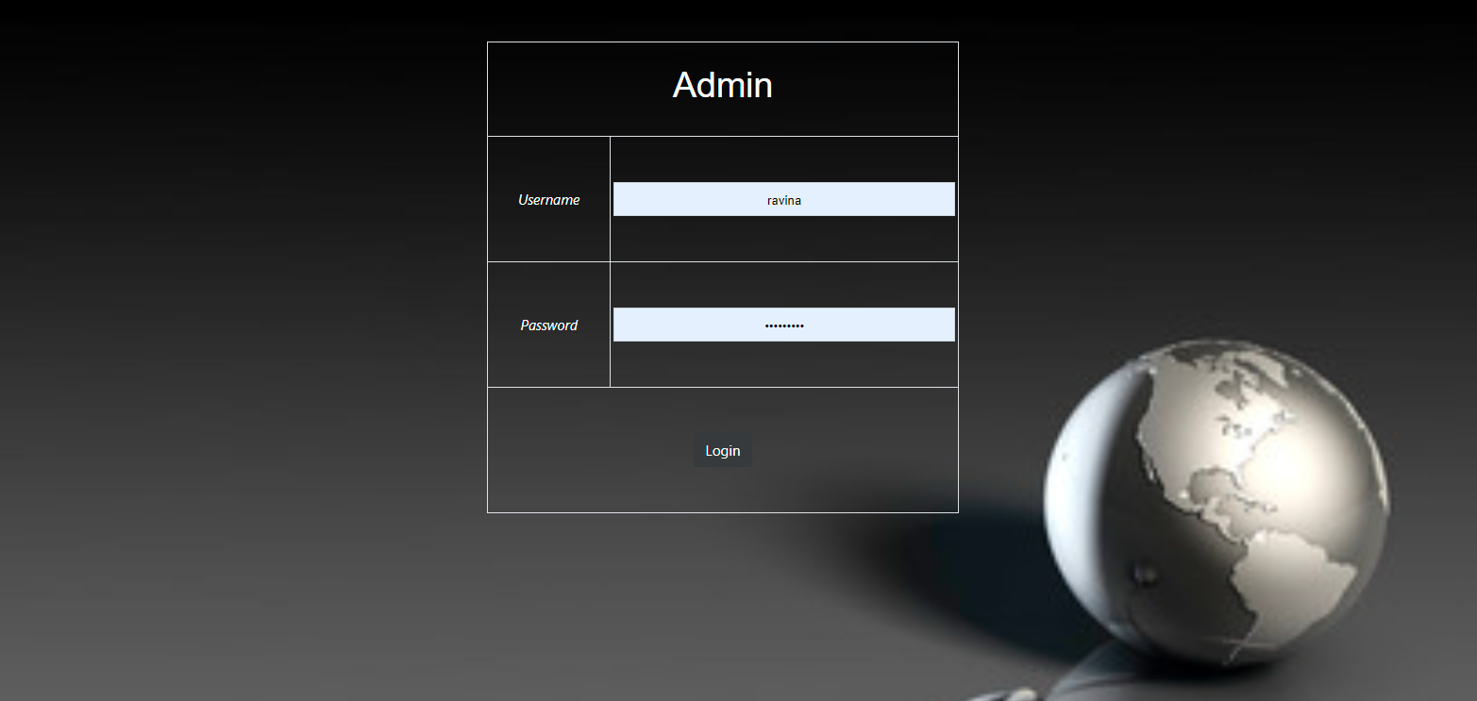

***Home Page***



***Placement Registration Page***

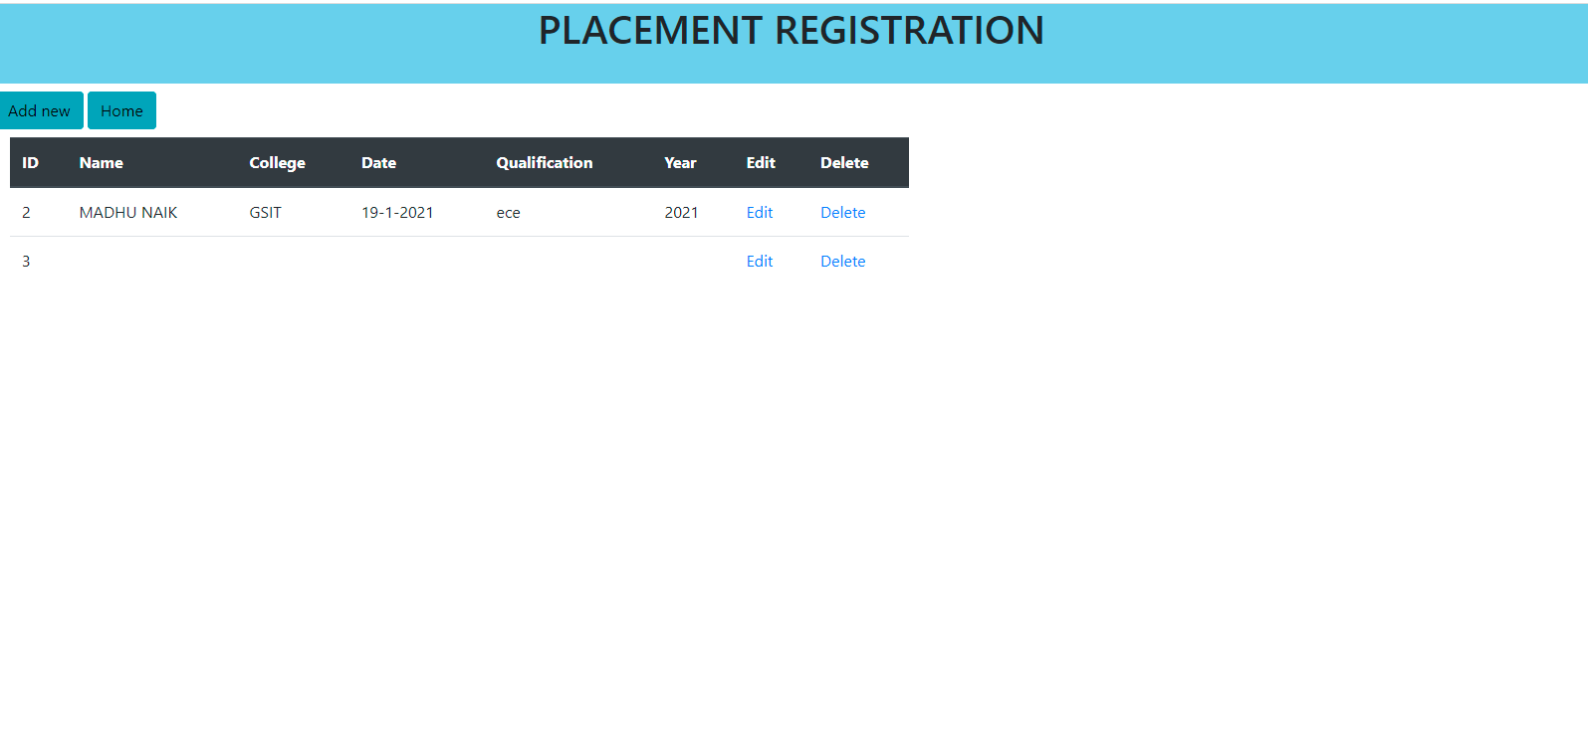

***Add Placement Data Page***

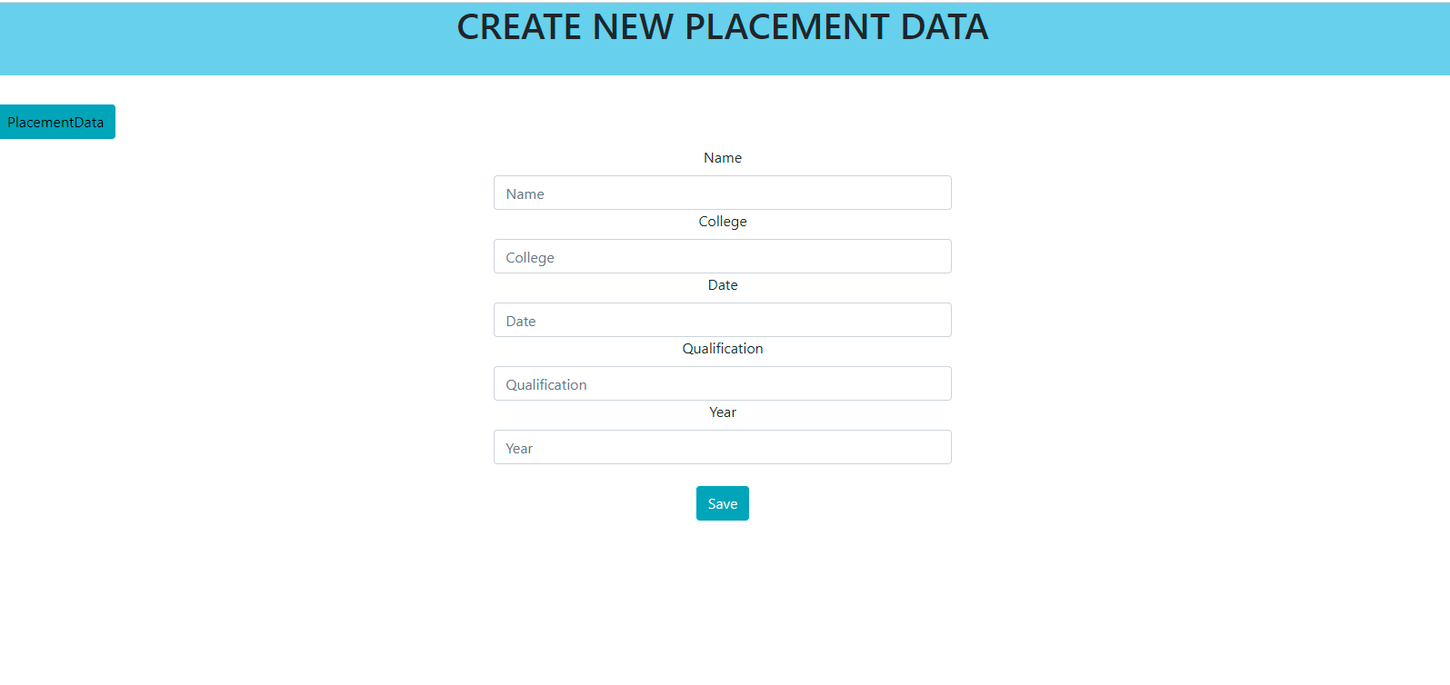

***College Registration Page***

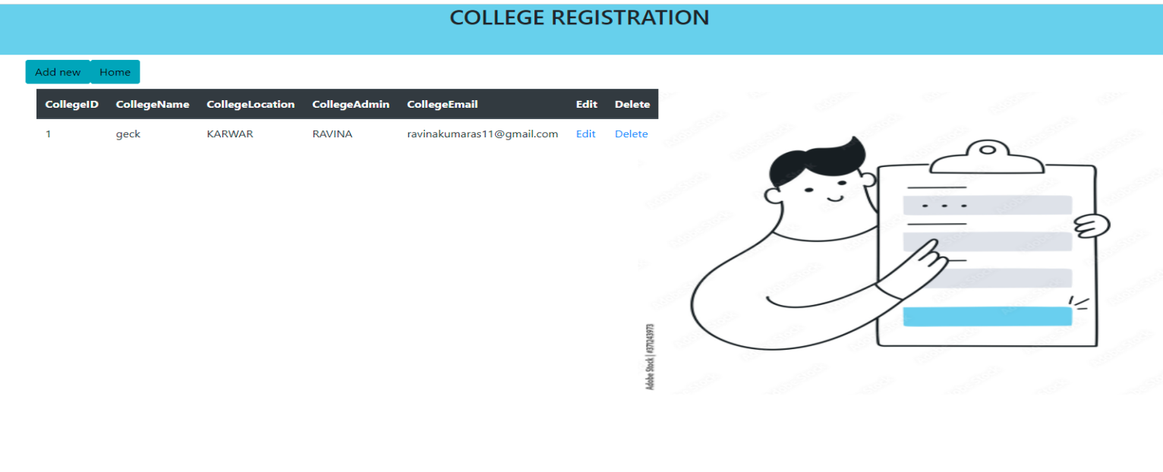

***Add College Data Page***

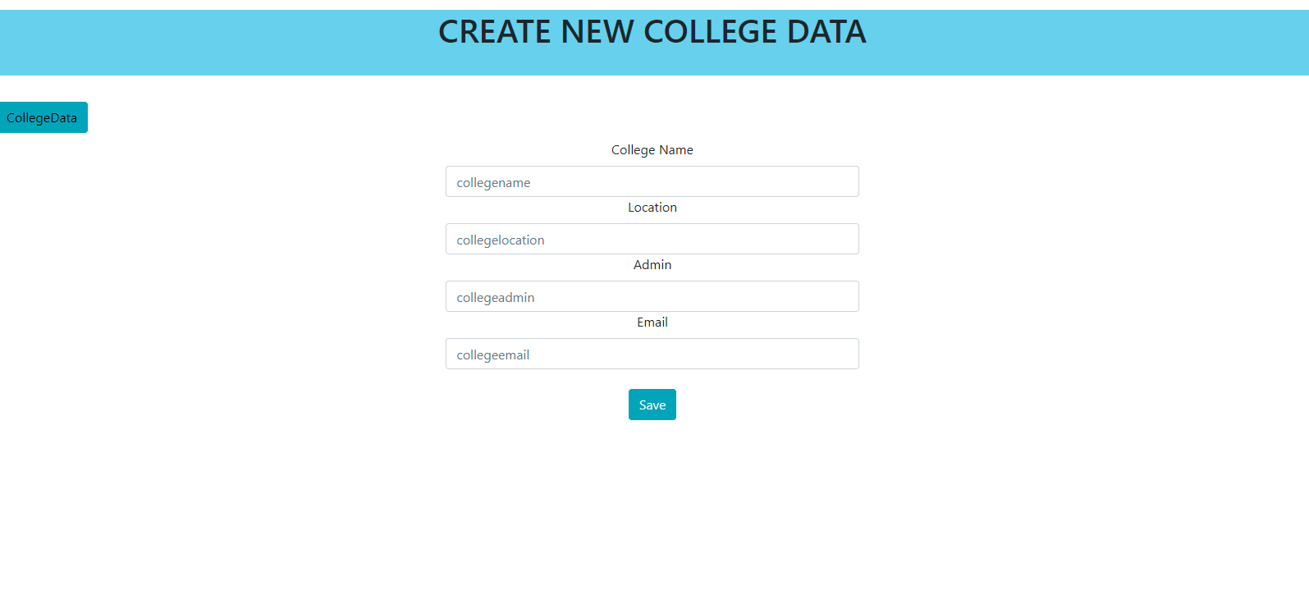

***Student Registration Page***

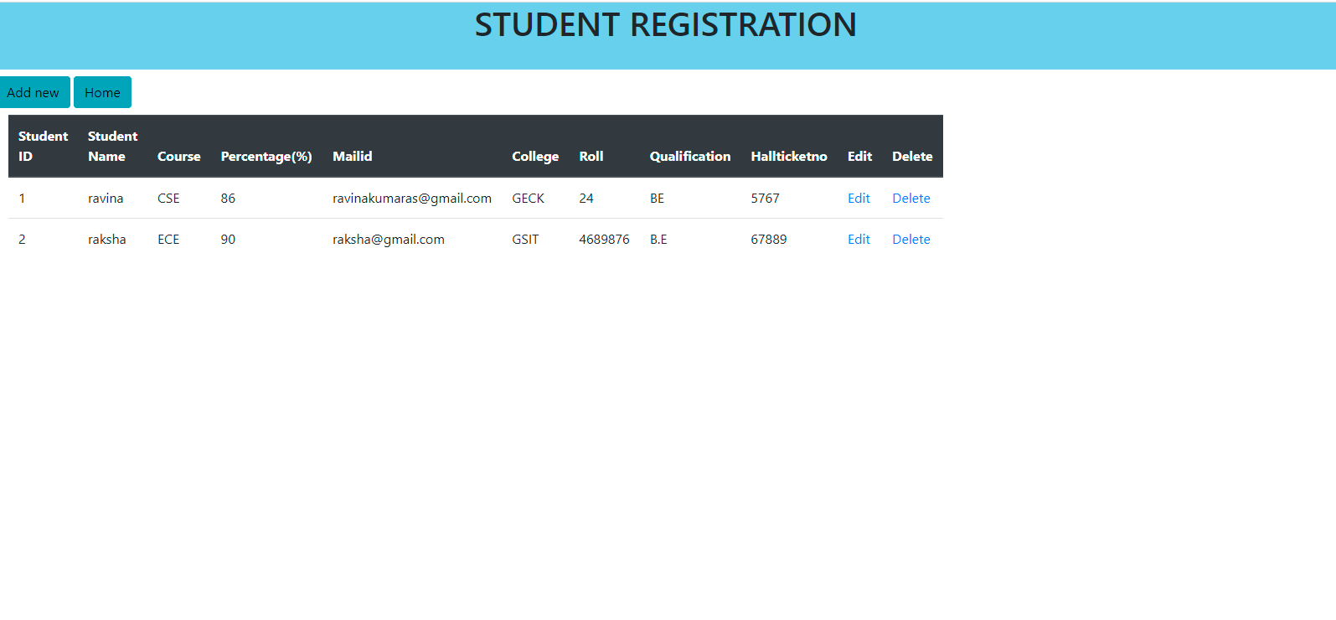

***Add New Student Data***

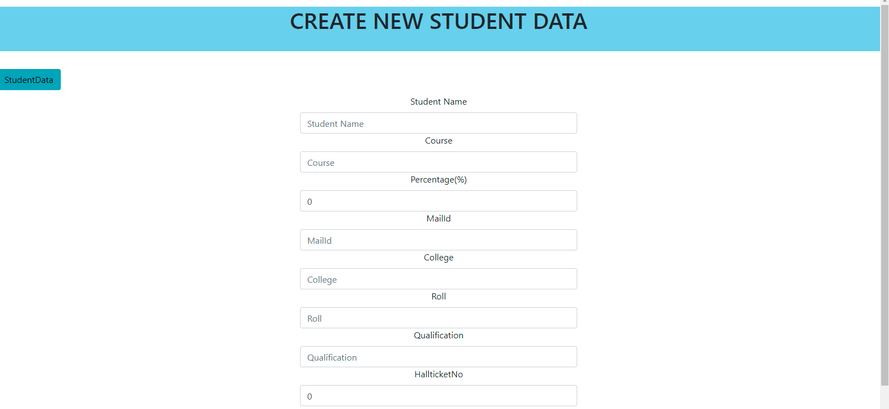

***About us page***

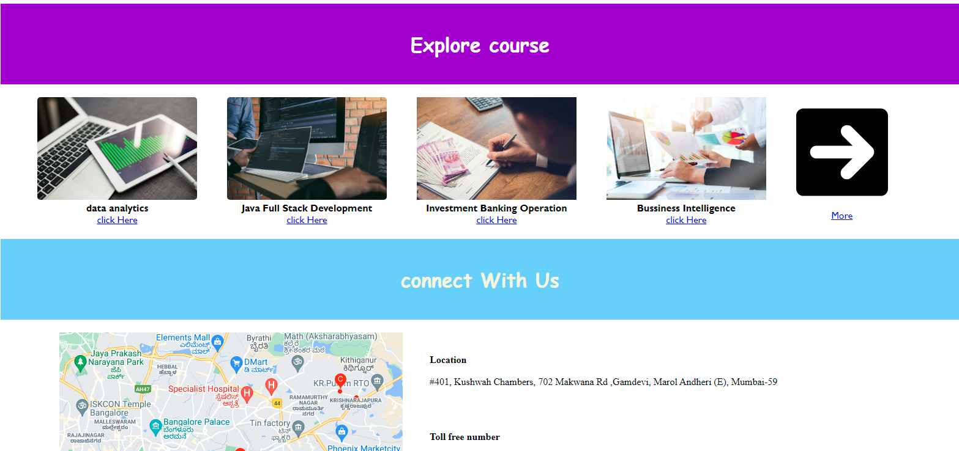

**THANK YOU**